**HOSTING A STATIC WEBSITE WITH S3**

**Steps:**

1. **Logon on to console and click on s3**
2. **Click on create bucket enter bucket name yahoo999 and select region MUMBAI and click create**
3. **Create a text file dps and type this is my and I am deepak**
4. **Right click on the dps.text and rename as dps.html**

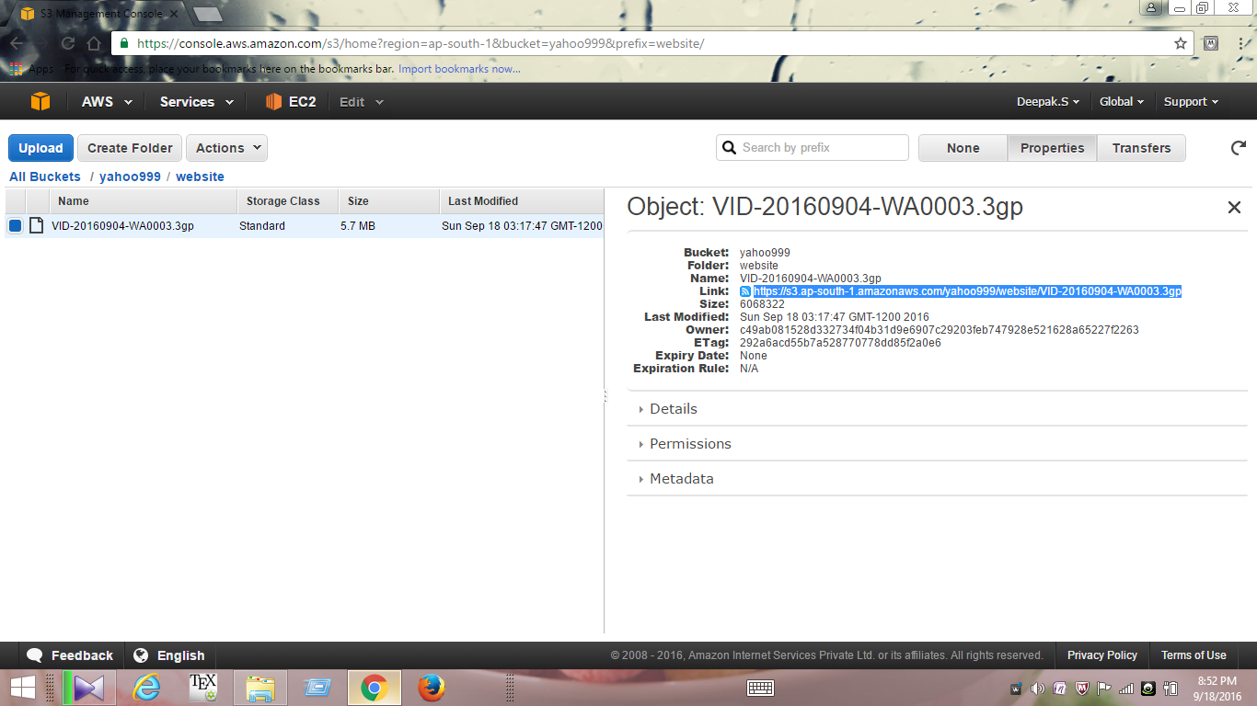

**5. Similarly upload a dps.html file to the bucket yahoo999**

**6. goto yahoo999>properties >static website hosting>enable web site hosting give the index name as dps.html**

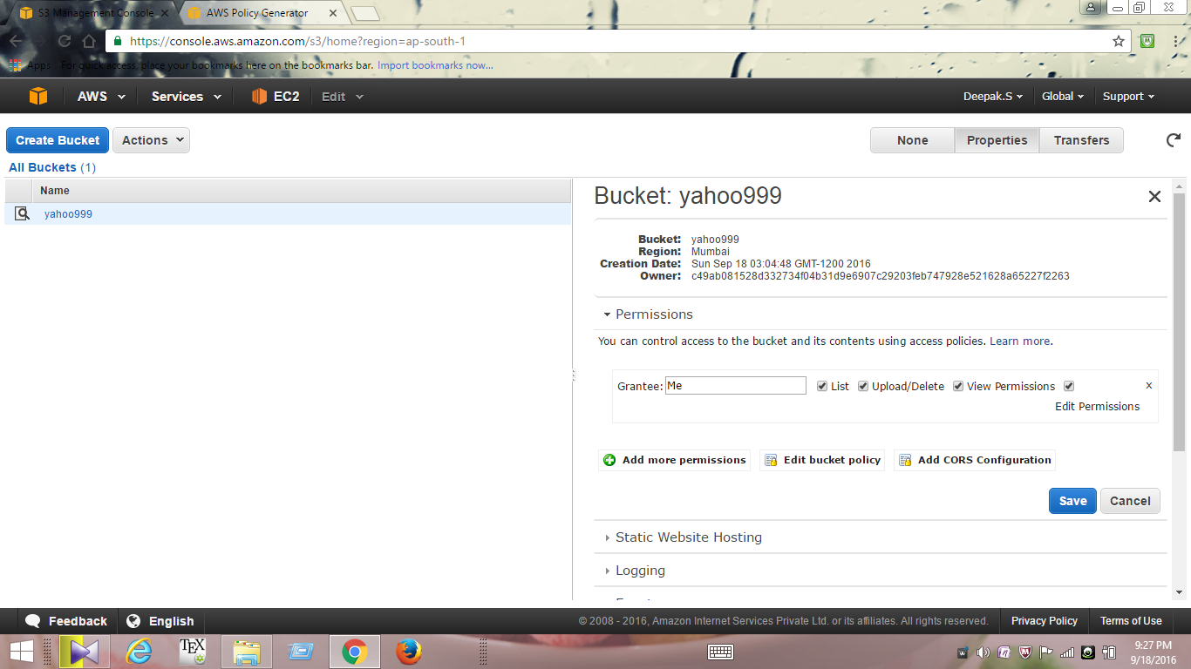

**7. yahoo999>bucket policy>aws policy generator**

**8. effect >allow and aws policy>s3 bucket policy**

**9. principal>* and actions>all**

**10. ARN>arn:aws:s3:::yahoo999**

**11. click on save two times**

**12.Right click on yahoo999>properties> add more permissions>everyone>save**

**13. Right click on dps.html>properties> add more permissions>everyone>save**

**14.dps.html >copy paste the url on the right top to access the static web page as below**

